UCLA Lipidomics Lab
Cell Collection Protocol
After consultation with the UCLA Lipidomics Lab personnel, you will receive sample collection racks. Internal clients will pick up racks via the COVID-19 “No Contact” Pick up Protocol (downloadable at uclalipidomics.net). External clients will be shipped racks. These racks are designed to store samples at -80° C and the housing is designed to safeguard samples during shipping. Each rack can hold up to 24 samples (Figure 1 & 2). The following is a brief outline of the suggested sample collection procedures.

Figure 1 Figure 2
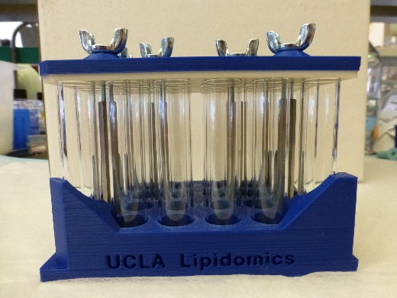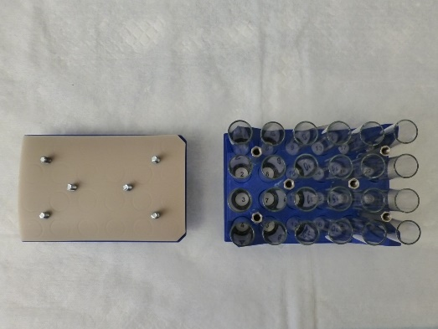

1. In preparation for your sample collection, you will want to remove the rack cover plate by loosening the 6 thumbscrews and lifting off the plate (see fig 2). You need not pull the thumbscrews out; and it is recommended that you leave the screws threaded through the cover plate and PTFE lined mat (Figure 2). The mat/cover should be handled by the edges. Should the mat be removed from the cover plate, please make sure that the tan side always faces the tubes. After removing the cover plate, check the glass tubes to make sure that none have been damaged in transit. You will receive a few extra tubes and you can replace a damaged tube if required. If the rack or tubes have suffered serious damage in transit, contact the UCLA Lipidomics Lab for replacement.
2. Prior to the collection, place the rack in the -20°C freezer to pre-chill the rack and tubes. If your collection will occur over an extended period of time, you may remove individual tubes to be placed over wet ice or dry ice. If you choose to remove tubes from the rack, be aware that there is a rubber gasket below each tube that may inadvertently be lifted out or stick to the bottom of the glass tube. Take care to return these to the appropriate rack well, as the tube will not seal against the mat without this gasket. If you remove tubes from racks, please number the outside of the tubes with an ethanol-resistant marker so that you can return the tubes to the appropriate numbered wells in the rack.
3. Prepare the sample submission sheet (downloadable at uclalipidomics.net) in preparation for the sample collection. This sheet requests some type of normalization value. Although an accurate cell count is recommended, you may use some other normalization method (i.e. protein assay). Cells may be collected by either scraping plates or trypsinizing cells. If you chose to scrape plates, you will want to prepare “mock” wells for cell count. If cells are collected by trypsinizing, a portion of the collected cells may be put aside for cell count.
4. Following cell collection, transfer cells in PBS or media (without FBS or lipid supplement) to the collection tube. The volume for transfer should be 0.5mL or less. Note the numbering in the rack under each tube and make sure this numbering of samples matches that in the sample submission sheet (Figure 3 & 4).
Figure 3 Figure 4
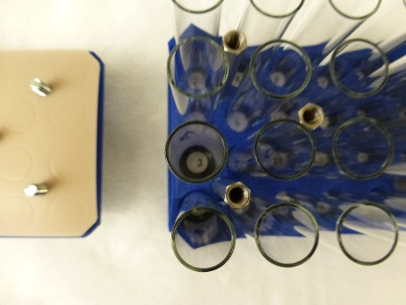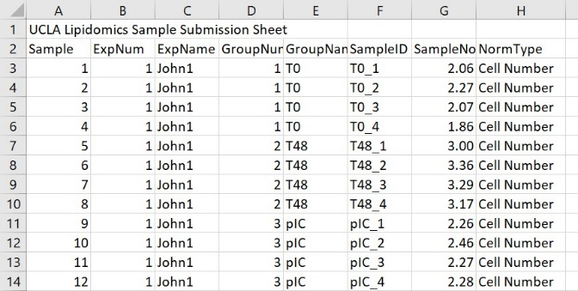
5. Once all cell samples are collected in the rack, seal the rack by aligning the cover plate with the base standoffs and tightening down the thumbscrews. Note that the beveled corners line up on the base and cover plate. You may need to guide the thumbscrews by observing the connection from the side.
6. Once you have fully tightened all 6 thumbscrews, return the rack to the provided Ziplock bag and freeze in a -80 freezer. Do not use any tools to tighten these screws; finger tightening is sufficient.
7. Internal clients may drop off these frozen racks at the lipidomics lab using the COVID-19 “No Contact” Drop Off Protocol (downloadable at uclalipidomics.net). Keep racks frozen by transporting on dry ice. External clients will ship these racks. For shipping, place the rack (or racks) in the provided frame. The two rack frame is 9” tall and should fit snugly in common Insulated polystyrene cooler (a 12” x 10” x 9” cooler is ideal). The frame can be surrounded on all sides by dry ice. Ship by FedEx next day delivery to:
Kevin Williams/UCLA Lipidomics
615 Charles E. Young Drive South
BSRB 257
Los Angeles, CA 90095

Email the lipidomics lab at lipidomics@mednet.ucla.edu to notify them of delivery and provide tracking information. It is strongly recommended that you ship your samples on a Monday, Tuesday, or Wednesday to ensure timely delivery should there be any delays. The UCLA loading docks are closed on weekends.

